Initial Output before inserting 9 as an input:

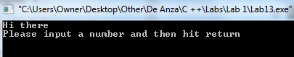

Output after inserting 9 as an input:

